**Evidence report**

Student: Nikol Stoyanova  
Student ID: 17069455

The first step taken to complete this assignment were to inspect the server through Swagger and get a general idea of all the endpoints that need to be implemented into the mobile app.

When creating a mobile application, I found useful to design wireframes to help me with the initial app’s structure, design and functionality *(Picture 1)*.

To manage my project better, a private GitHub repository was created to version control my app and consistently update the code when needed *(Picture 2)*. Version Control was helpful as to save my project’s progress, save all undergoing code changes and provide me with an online accessible copy of my work up to date. Moreover, it helped me when I had to recover an earlier version of my code or compare changes that I have made to my files. I have used GitHub continuously through my project development *(Picture 3)*.

When initialising the GitHub repository to hold my project, it was created with a README file which was later on updated *(Picture 4)*. A .gitignore file was added as to when committing a newer version of my project I don’t commit the node modules.

For the code style parts of the AirBnb guide was used. For example, a class is always used to avoid manipulating prototypes directly and the key word ‘extends’ is used when there is an inheritance *(Picture 5)*. A constructor is only specified when needed *(Picture 6)*. All modules are imported correctly so there are no errors or not needed modules *(Picture 7)*. More of the guide is followed and that can be seen throughout the whole project code.

To manage the project better, some of the principles of the Agile Manifesto were followed. There is an evidence of continuous development of the app with attention to the technical excellence. *(Picture 8)*.

*Picture 1*. Wireframes

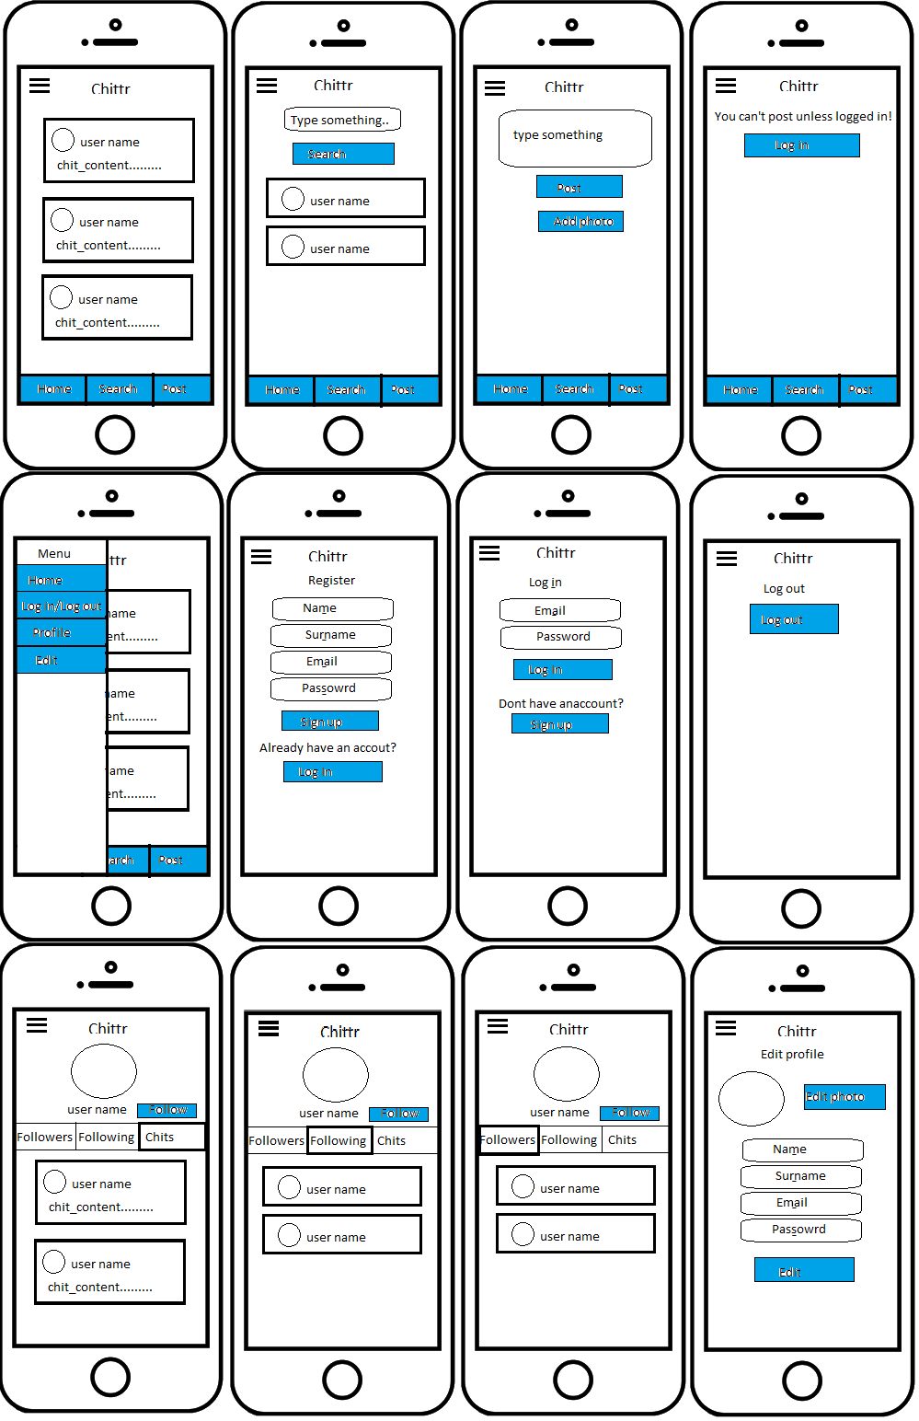

*Picture 2*. GitHub repository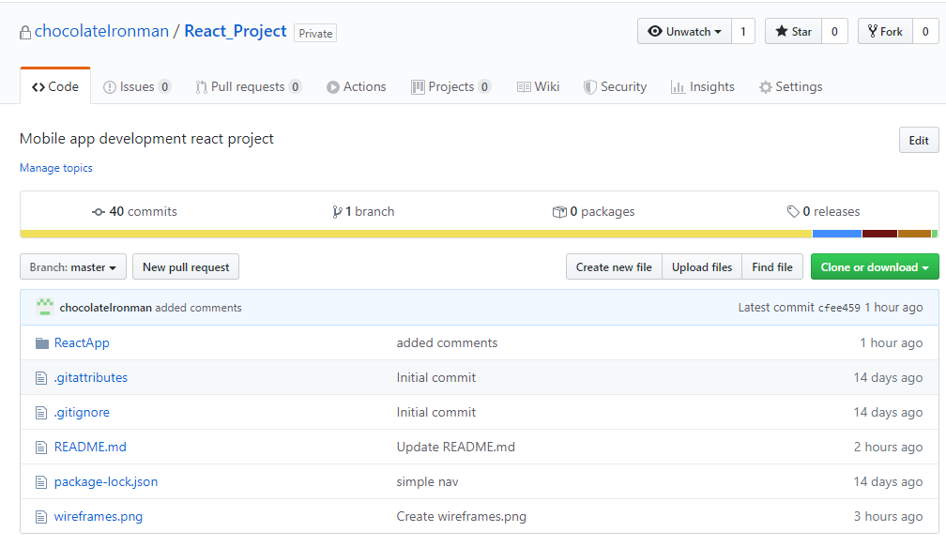

*Picture 3*. Continuous use of GitHub version control 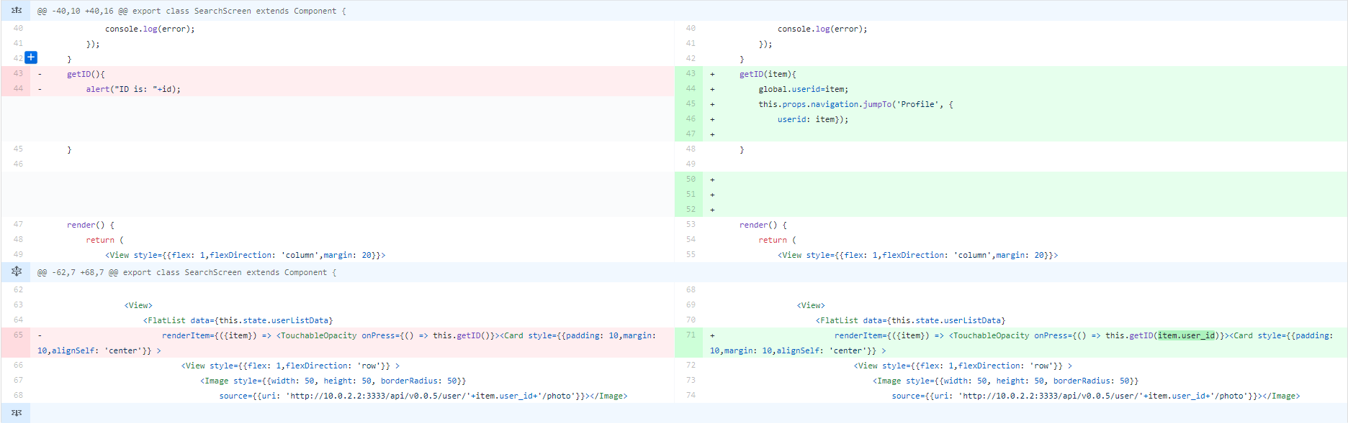

*Picture 4*. README.dm file 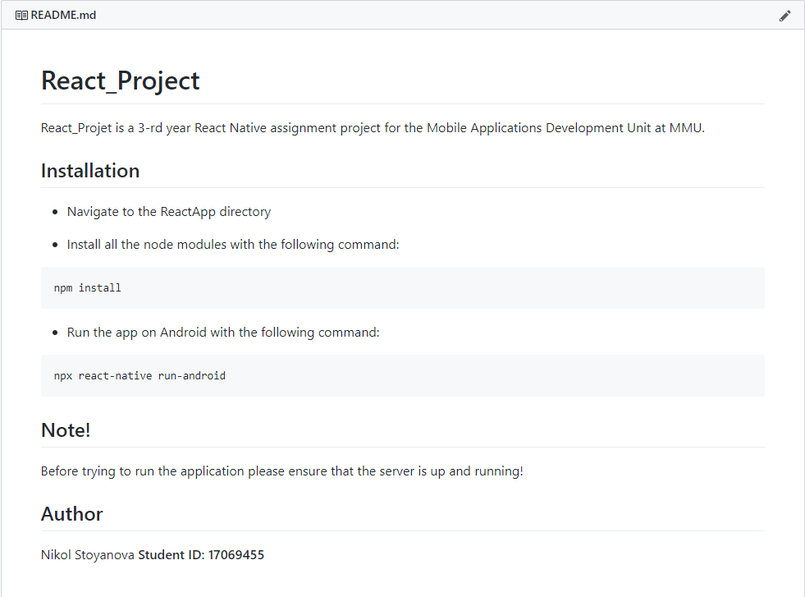

*Picture 5*. Style guide used for class



*Picture 6*. Style guide used for constructor

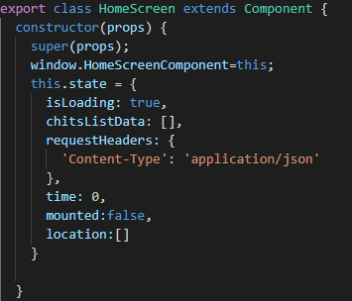

*Picture 7*. Style guide used for importing of modules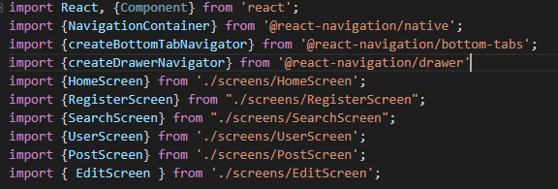

*Picture 8*. History of commits showing continuous development following the Agile Manifesto